DB Snapshot - Testing - SQL Server. (Author: Rohit Garg)
https://gallery.technet.microsoft.com/scriptcenter/Creation-Deletion-of-68d2b9aa
Scenario:
Create new Database Snapshot & drop old Database Snapshot on set regular interval on Database Mirroring.

Setup 2 scripts: Creation of snapshot & Deletion of snapshot. We can schedule a SQL agent jobs with 2 steps.

- Database Snapshot is very COOL feature introduced with SQL Server 2005.
- You can make snapshot on user database in online mode along with database in restoring mode, only in case of Database Mirroring.
- Below script will work in both cases.

Note:
1. Sample DBName here: Test
2. In below TSQL Script, Change the Name of the Database highlighted in GREEN color to generate a DB Snapshot of your required DB.
3. Under FILENAME, replace " E:\SQLData\Default" value with your DB MDF File Path.
use master
go
--Step 1 :- Creates the required DB Snapshot.

DECLARE @CREATE_SS VARCHAR(MAX)
DECLARE @DT VARCHAR(100)
SET @DT = REPLACE(REPLACE(REPLACE(CONVERT(VARCHAR,GETDATE(),120),'-','_'),' ','_'),':','_')
SET @CREATE_SS =
'CREATE DATABASE TEST_'+@DT+' ON
( NAME = TEST, FILENAME =''E:\SQLData\Default\TEST_'+@DT+'.SS'' ) AS SNAPSHOT OF TEST'
EXEC (@CREATE_SS)

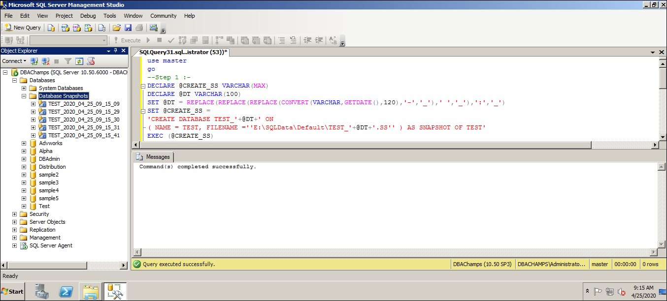

--Step 2 :- Deletes the mentioned Database Old or Aged DB Snapshot.

IF(SELECT COUNT(*) FROM SYS.DATABASES WHERE SOURCE_DATABASE_ID = DB_ID('TEST'))>1
BEGIN
DECLARE @DROP_SS VARCHAR(MAX)
DECLARE @SS_NAME VARCHAR(100)
SELECT TOP 1 @SS_NAME = NAME FROM SYS.DATABASES WHERE SOURCE_DATABASE_ID = DB_ID('TEST')
ORDER BY CREATE_DATE ASC
SET @DROP_SS = 'DROP DATABASE '+ @SS_NAME
EXEC (@DROP_SS)
END
Observation:
Out of the 5 DB Snapshots, the 1st one (TEST_2020_04_25_09_15_09) will get deleted on executing Step-2 script.
